Quarterly Newsletter

Prayatna Nepal January - March 2026

Validation Consultation
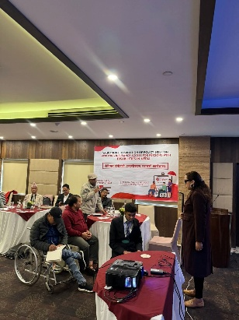
On February 24, 2026, Prayatna Nepal held a Validation Consultation in Kathmandu on the Policy Brief on Improving Insurance Access for Persons with Disabilities in Nepal. The event brought together key stakeholders for an open, collective discussion where the policy brief's key findings were presented. It also served as a valuable opportunity to further refine and strengthen the recommendations, ensuring they genuinely reflect the voices and lived experiences of those most affected.

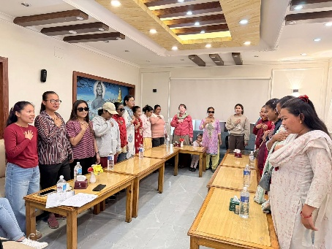
Feminist Dialogue Series
On March 19, 2026, Prayatna Nepal organized a Feminist Dialogue Series in Kathmandu, bringing together 21 women with disabilities. The event provided a safe and inclusive space where participants openly shared their lived experiences and voices. It also sparked meaningful conversations around practical, actionable ways to overcome the challenges they face in their daily lives.

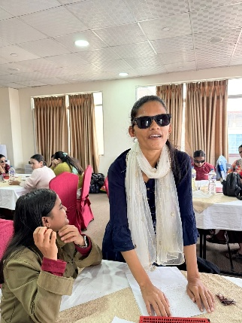
Capacity Development
Prayatna Nepal organized a two-day Capacity Development Training for 17 members of Sisters of Prayatna Nepal from Gandaki and Lumbini Provinces on March 25–26, 2026. Designed to sharpen practical skills and foster strong leadership within the network, the training covered key areas including leadership, negotiation, communication, networking, team building, management, and meeting minute writing.

Kanthari Alumni visit
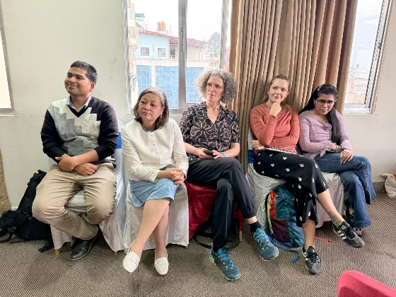
A group of kanthari alumni and representatives from kanthari Institute, Switzerland, visited and observed the Capacity Development Training organized for members of Sisters of Prayatna Nepal from Gandaki and Lumbini Provinces. They offered their feedback on the training and expressed great admiration for the impressive strides made by Ms. Sarita Lamichhane, a kanthari alumna and Founder Chairperson of Prayatna Nepal in her dedicated work in the field of visual impairment.

Contact us at:
Website: www.prayatnanepal.org
Email: info@prayatnanepal.org
Phone no.: 9851312433

