Quarterly Newsletter

Prayatna Nepal April - June 2026

Professional Counselling
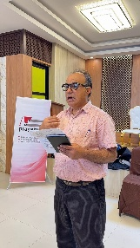
On April 3, 2026, Prayatna Nepal completed one-day Professional counselling session on Sexual and Reproductive Health and Rights (SRHR) led by Dr. Khem Karki. The session comprised of useful information on preventing birth defects and disabilities with major focus on TORCH profile test. A total of 27 women and girls with visual impairments, visually impaired couples, and OPD representatives took part in the session.

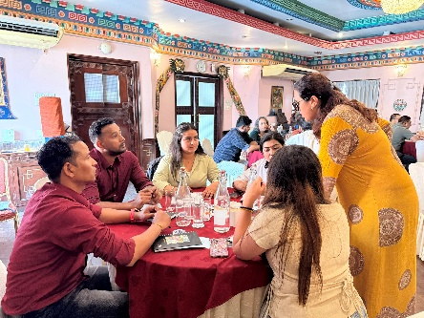
DID Workshop
Prayatna Nepal conducted Disability Inclusive Development Workshop on April 16 and May 25, 2026. One of the workshops was facilitated by Ms. Sarita Lamichhane and Mr. Shiva Acharya and the other was facilitated by Ms. Lamichhane and Mr. Krishna Bahadur Gahatraj. The workshop was organized to promote inclusive society for representatives from National and International Organizations.

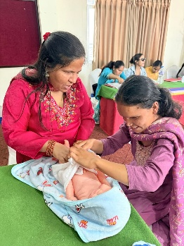
Sexuality Training
Prayatna Nepal conducted a five-day Sexuality training from April 26–30, 2026 for visually impaired women and girls. The training covered a wide range of SRHR issues from sex, gender, and consent to contraception, pregnancy care, and online safety. The main highlights included hands-on with contraceptive devices, open discussions on abortion and LGBTIQ+ identities, practical Facebook privacy lessons, and practicing newborn care with a dummy baby.

Validation Workshop
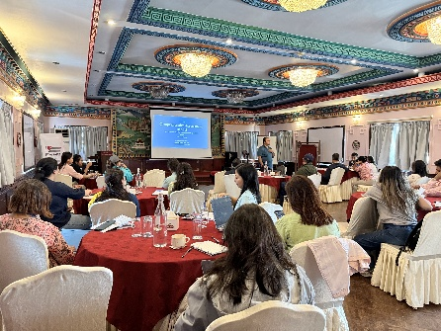
Prayatna Nepal organized a validation workshop in Kathmandu to present draft findings of KAP-A Audit on May 11,2026. Researcher Maheshwor Ghimire presented findings from 10 rights-based organizations which showed that many organizations that publicly champion human rights fall short when it comes to being accessible either in their physical spaces, digital platforms, hiring practices, or decision-making processes. The feedback from the workshop will be incorporated into the final report before publication.

Fightback Training
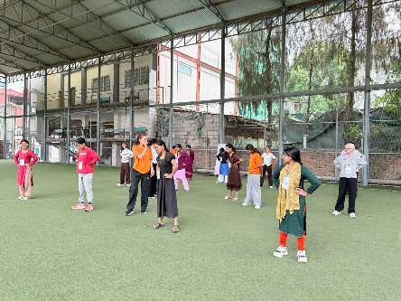
From May 13-17, 2026, Prayatna Nepal, completed a five-day self-defense training for visually impaired women and girls in partnership with Fight Back Nepal. The sessions blended theory and practice including how to recognize violence, manage fear, and stay safe online, alongside hands-on techniques like the SOS block, palm strike, ear strike, eye poke, and even using a white cane as a self-protection tool. Participants also learned Jeff Cooper's Color Code system to stay situationally aware.

Project Initiation Meeting
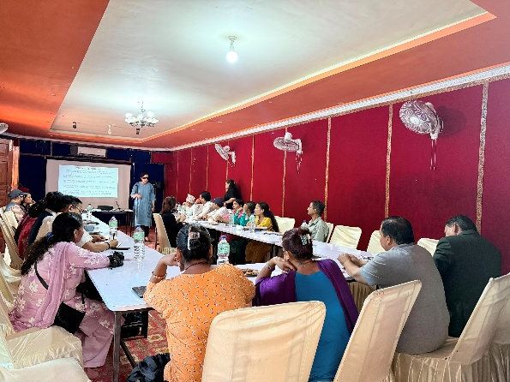
On May 20, 2026, Prayatna Nepal conducted kick off meeting of the project "Digital Desires, Digital Dangers: Intersecting Pleasure, Power, and Protection in Online Spaces" with a stakeholder mapping meeting in Tulsipur, Dang. 18 participants from local government, disability rights groups, media, and civil society came together to discuss the realities facing women and girls with disabilities, both online and offline. Conversations ranged from social media harassment and blackmail to inaccessible banking systems and menstrual hygiene challenges.

World Assistive Day Celebration
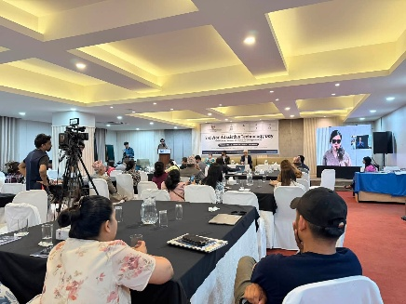
On June 4, 2026, on the occasion of the 3rd World Assistive Technology Day, the Department of Information Technology (DoIT) led a National Policy Dialogue on Assistive Technology and Digital Accessibility in Kathmandu with Prayatna Nepal as one of the key co-organizers. Experts and persons with disabilities came together to speak openly about the gaps that still exist. One thing everyone agreed on was assistive technology is a right, not a favor. The day ended on a hopeful note with the government confirming dedicated funding for assistive technology.

Accessible Digital Content Development
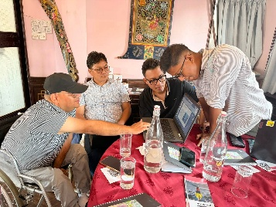
Prayatna Nepal conducted Accessible Digital Content Workshop on June 8 & 22, 2026. The workshop brought together 31 & 30 stakeholders from UN agencies, INGOs, government, and the private sector for a one-day workshop on accessible digital content each. Participants got both the theory and hands-on practice, and importantly, gained firsthand insight into how people with visual impairments actually navigate the digital world.

Podcast Series Orientation
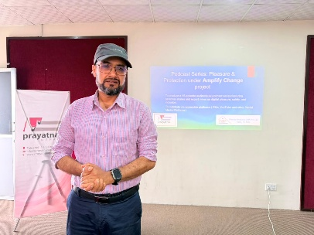
On 10 & 11 June, 2026, Prayatna Nepal hosted a two-day podcast orientation for women with disabilities, training them to become hosts for an upcoming 15-episode podcast series covering disability, sexuality and digital rights. Facilitator Toya Ghimire guided participants from podcast basics to camera confidence and question structuring. On day two, each participant hosted a live practice episode with a real guest. Most participants hadn't expected much from themselves but surprised themselves by the end.

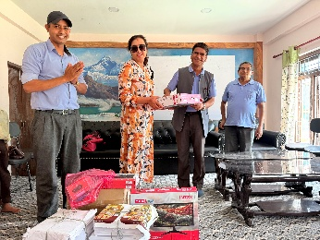
Education Material Distribution
On June 26, 2026, Prayatna Nepal handed over two desktop computers and 4,000 Braille papers highlighting the importance of inclusive education and objectives distributing educational support materials to support the educational needs of 11 visually impaired students studying at Chandeswhwori Secondary School, Nuwakot.

Contact us at:
Website: www.prayatnanepal.org
Email: info@prayatnanepal.org
Phone no.: 9851312433

